**React**

**10. ReactJS-HOL - Create a React Application named “officespacerentalapp” which uses React JSX to create elements, attributes and renders DOM to display the page.**

**CODE:**

**App.js**

import React from 'react';  
import dbsImage from './dbs.jpg';

import startupImg from './starthub.webp';   
  
function App() {  
 const heading = "Office Space, at Affordable Range";  
  
 const officeList = [  
 {  
 Name: "DBS",  
 Rent: 50000,  
 Address: "Chennai",  
 image: dbsImage  
 },  
 {  
 Name: "Startup Hub",  
 Rent: 70000,  
 Address: "Bangalore",  
 image: startupImg  
 }  
 ];  
  
 return (  
 <div style={{ textAlign: 'center', fontFamily: 'Arial' }}>  
 <h1 style={{ backgroundColor: '#a8e6e6' }}>{heading}</h1>  
  
 {officeList.map((item, index) => {  
 const rentColor = item.Rent <= 60000 ? "red" : "green";  
  
 return (  
 <div key={index} style={{ marginTop: "20px" }}>  
 <img  
 src={item.image}  
 width="25%"  
 height="25%"  
 alt="Office Space"  
 style={{ marginBottom: '10px' }}  
 />  
 <h3><strong>Name: {item.Name}</strong></h3>  
 <h3 style={{ color: rentColor }}>  
 <strong>Rent: Rs. {item.Rent}</strong>  
 </h3>  
 <h3><strong>Address: {item.Address}</strong></h3>  
 </div>  
 );  
 })}  
 </div>  
 );  
}  
  
export default App;

**dbs.jpg**

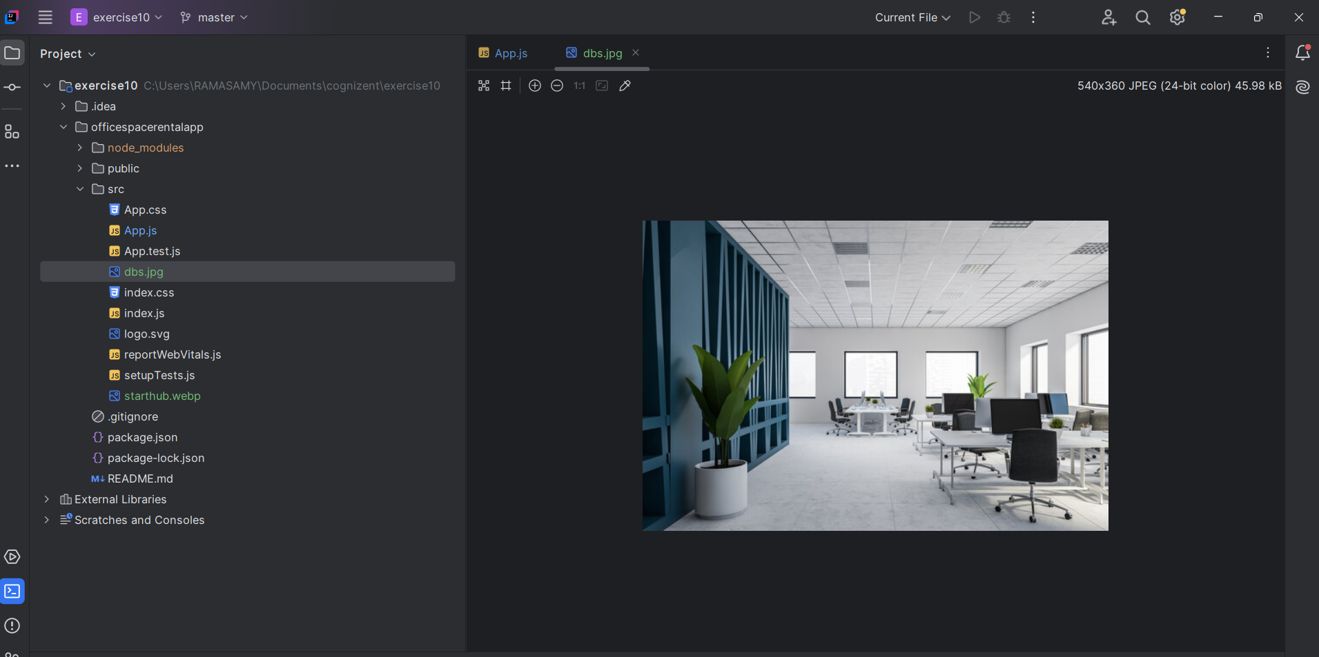

**Starthub.webp**

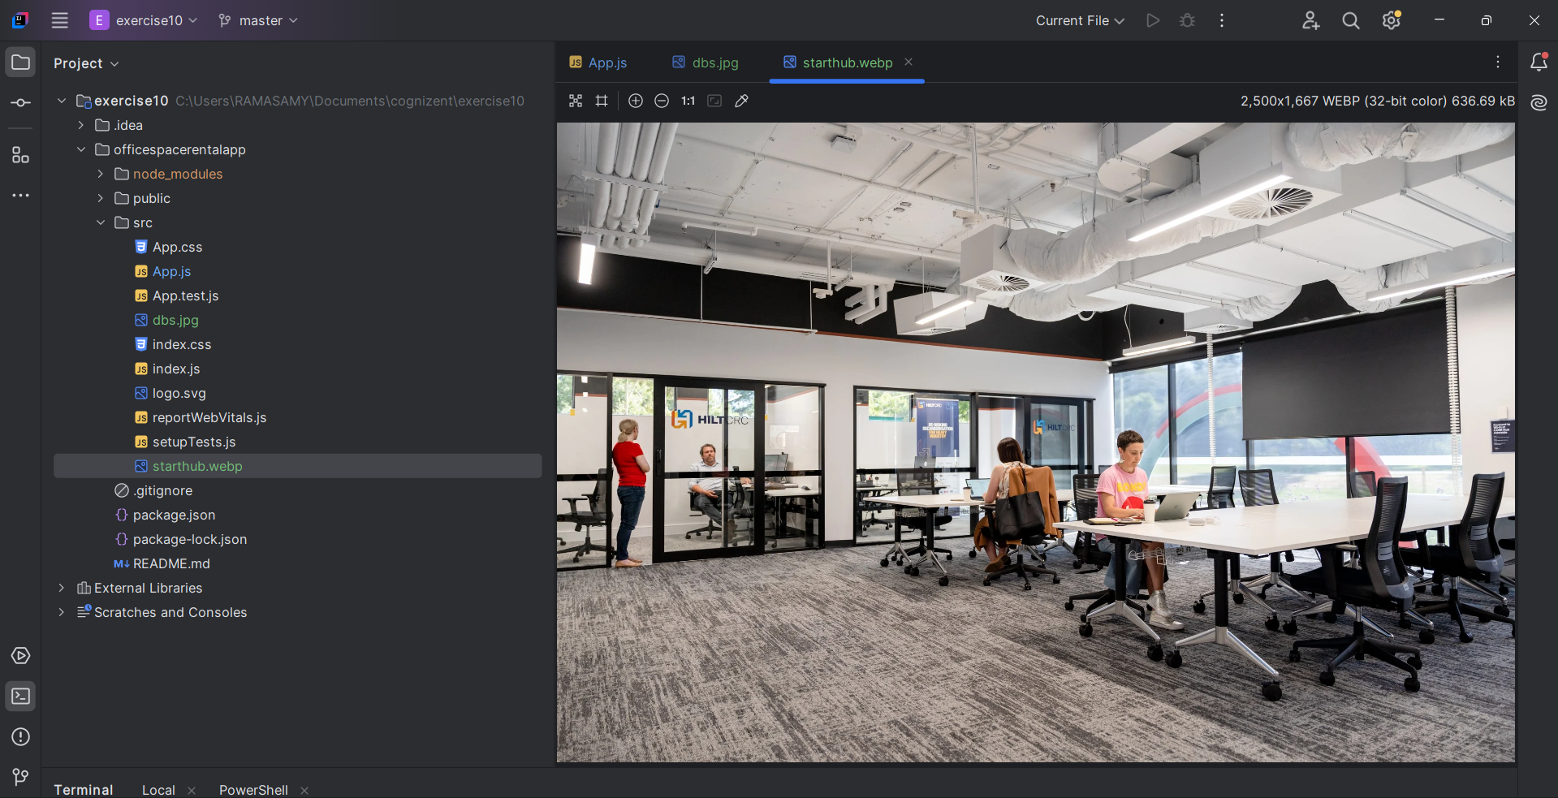

**OUTPUT:**



